**Laptop Management Application**

This is a small Window Application to load data from Excel and SQL Server, and update data from the grid view to these data sources. The application also provides features to add a new record to the grid view as well as update and delete a record on the grid view.

# GUI

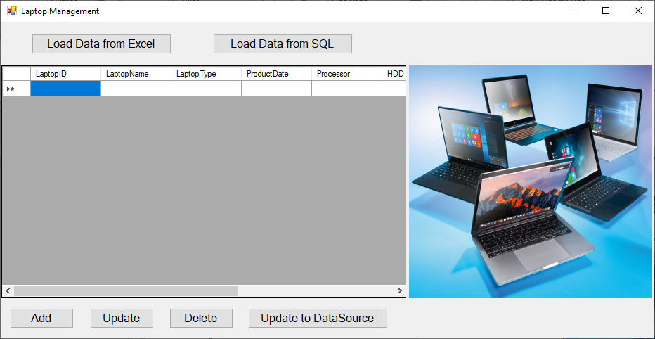

# Features

## Load Data from Excel

Allow users to load data from an Excel file.

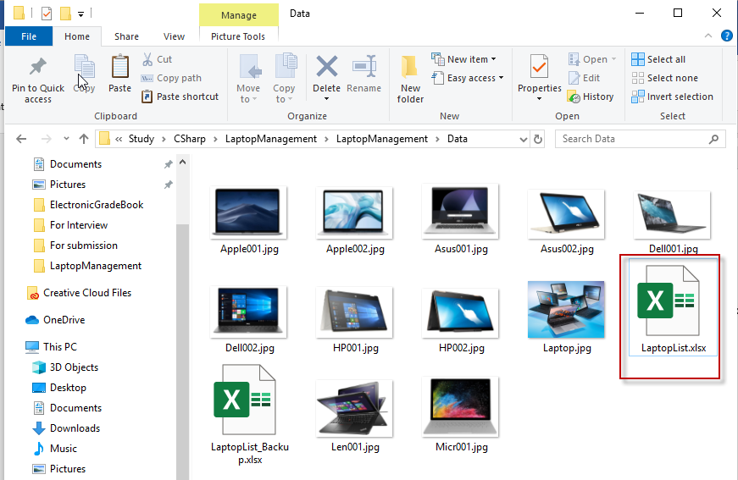

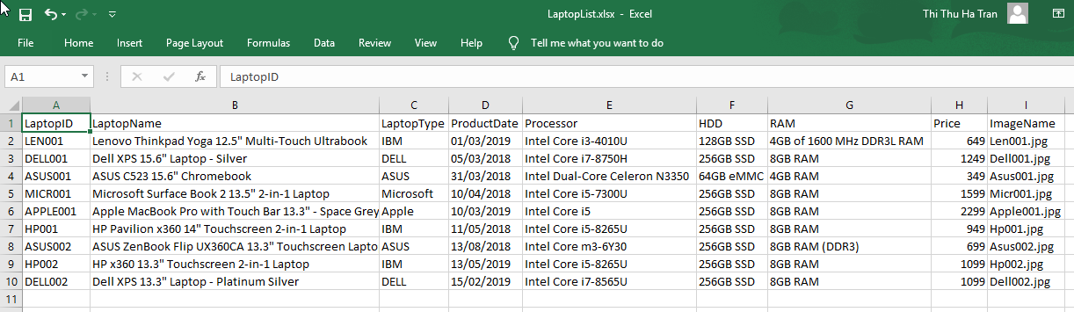

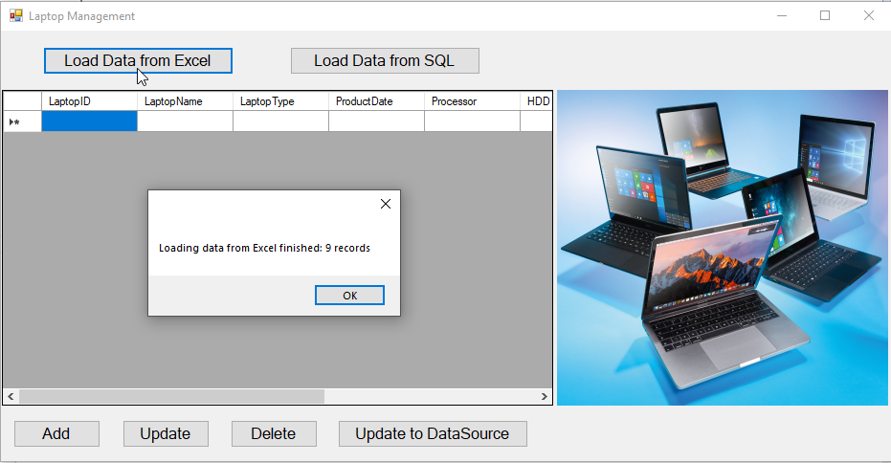

When selecting a record on the grid view, the corresponding image will be displayed

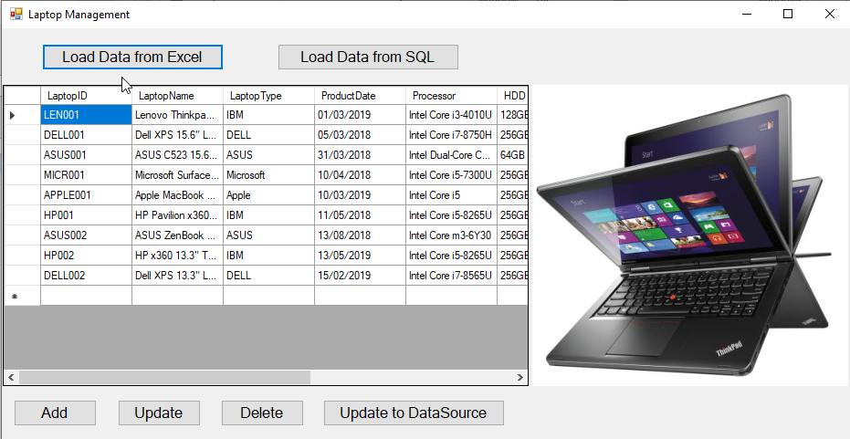

## Load Data from SQL

Allow users to load data from an SQL database.

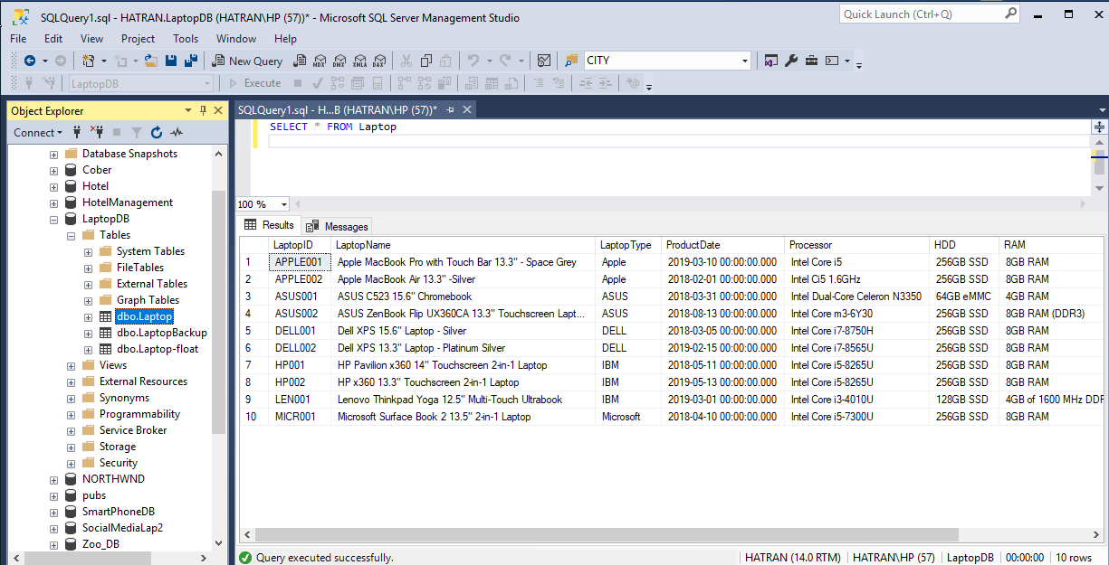

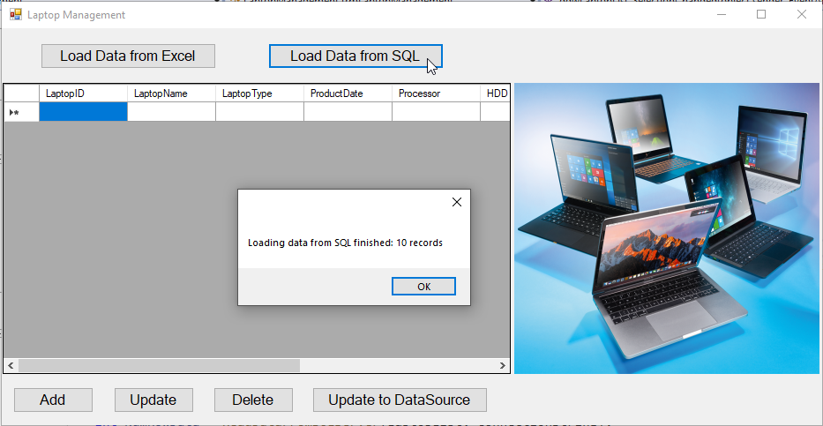

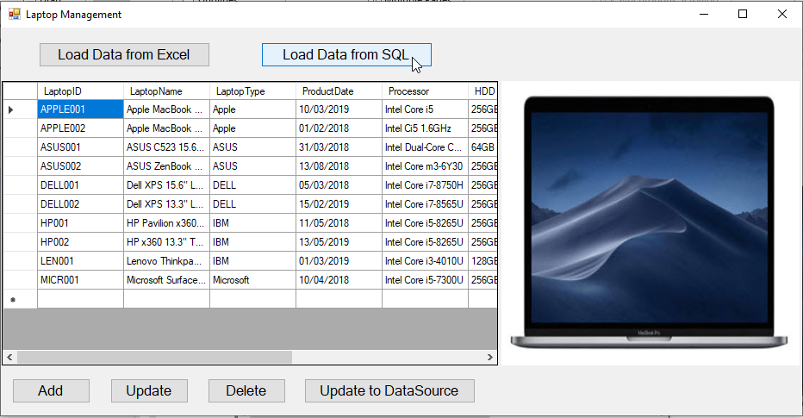

## Add

Allow users to add a new record to the grid view (the new record is current hard coded).

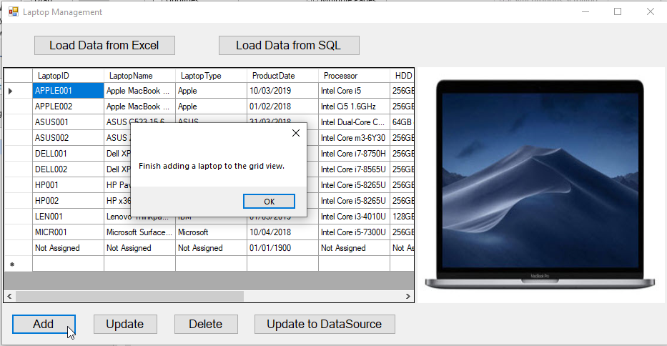

## Update

Allow users to update a record on the grid view. Price column only accepts digits, the field will be read-only if typing not-digit chars.

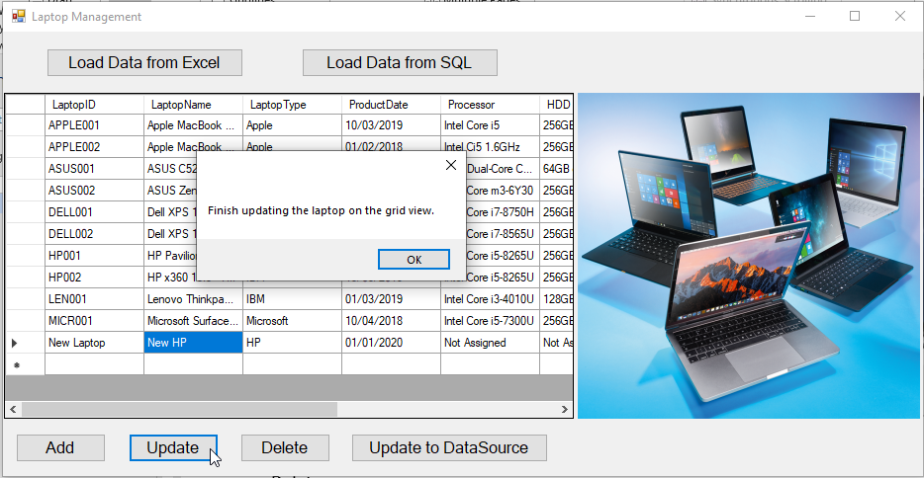

## Update to Data Source

Allow users to update data on the grid view to the current data source.

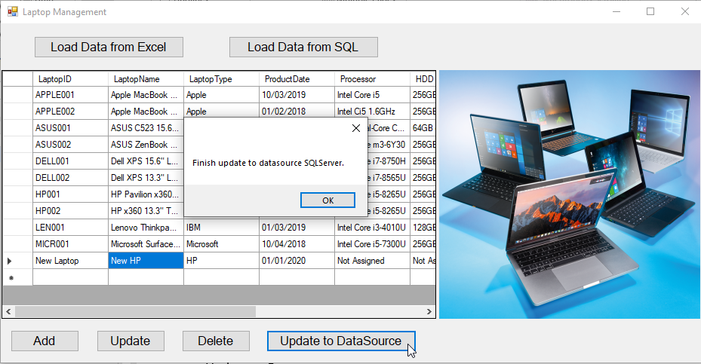

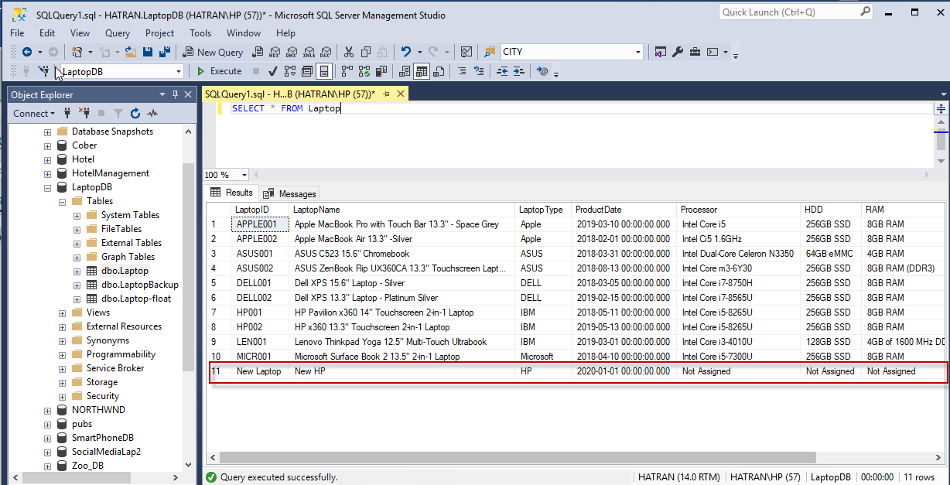

## Delete

Allow users to delete the selected record on the grid view.

